THANK YOU FROM

<Recipient>

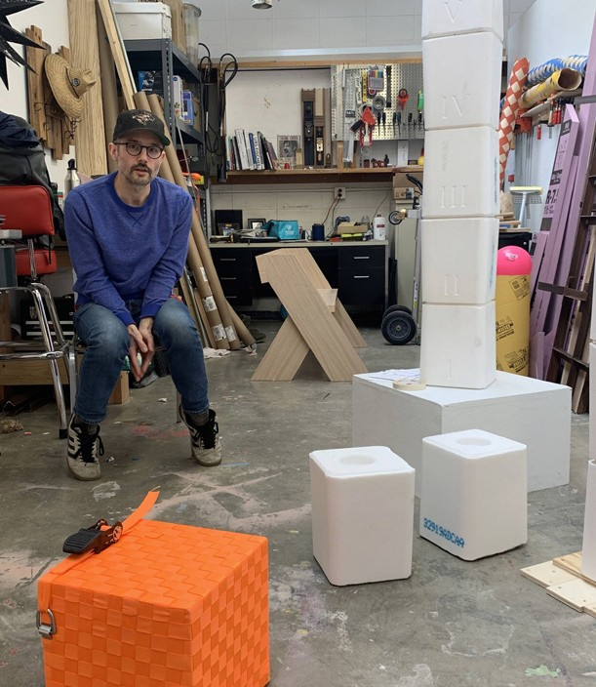

Image taken March 3, 2020, shortly before the COVID-19 pandemic.

DEGREE: Master of fine arts
MAJOR: Art
GRADUATION: Spring 2022
AWARD: [redacted]
Dear <Salutation>,

As I have outlined many of my accomplishments over the past 12 months, and those yet to be achieved, I would like you to know that they would have been so much harder to achieve without the gracious gift you have given me. Your gift has allowed me the opportunity to solely focus on my academic career and creative research/practice.
Since receiving this award in 2019, my mom has been sending me your [redacted] books, [redacted], and I have become quite familiar with some of your writing. This last Christmas (2020) my mom and I unknowingly both exchanged your [redacted] book as gifts to each other. I grew up listening to the Beatles and found your book insightful and a way to connect with my mom, especially during the pandemic.
Thank you for that opportunity!

Currently, I am working on self-publishing a perfect-bound exhibition catalog of my master of fine arts qualifier exhibition, “Against the Wall.” It will include my artist statement, images of my work and exhibition views, and writing from my master of arts thesis response paper. I will be sure to send you a copy. Who knows, maybe you both could attend my MFA exhibition opening in the spring of 2022?
I am thrilled that I will have this next year to focus completely on my practice and am truly grateful for these opportunities and experiences, as I would not be here without your generous financial support. I look forward to keeping you updated as my graduate career at UW–Madison continues to develop and progress.
Sincerely,

<Recipient>

UNIVERSITY OF WISCONSIN | SCHOOL OF EDUCATION | education.wisc.edu

